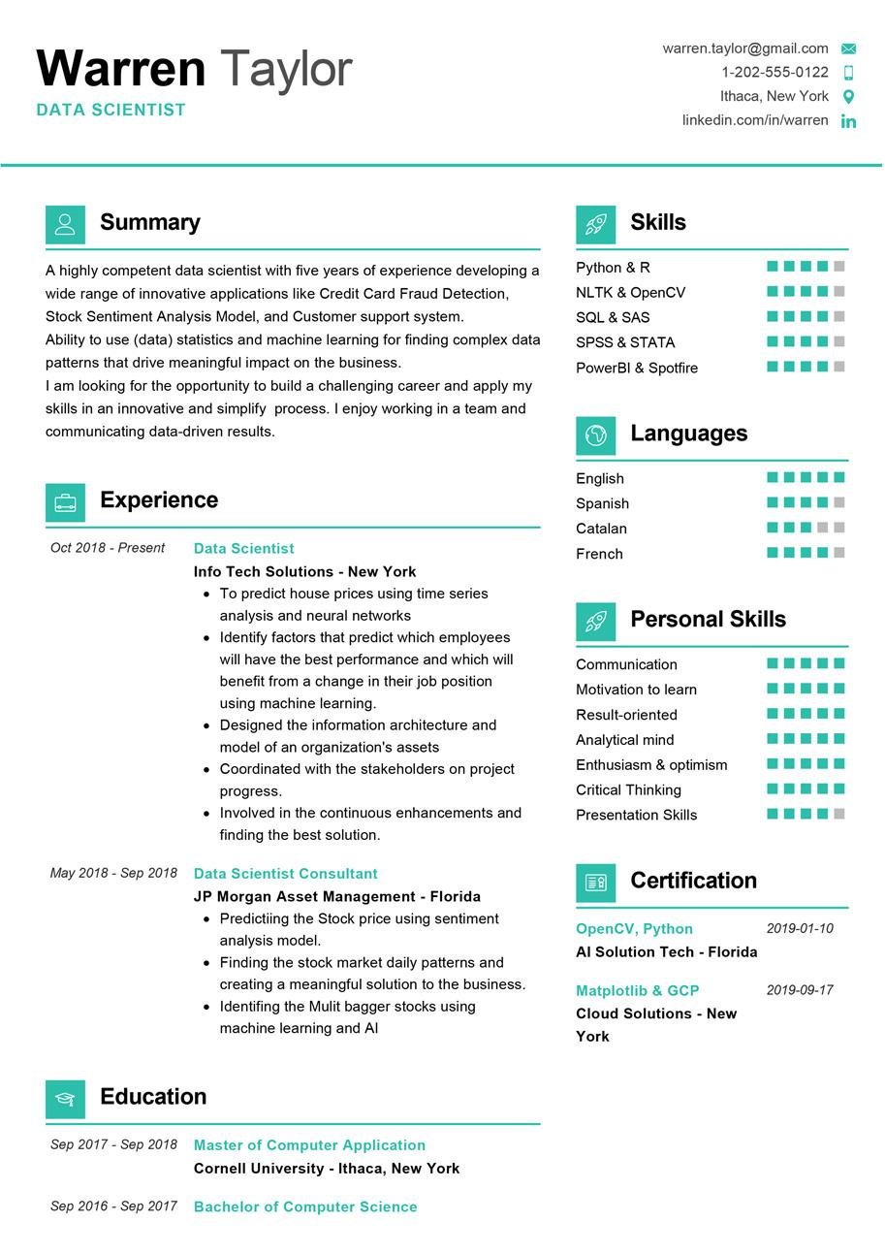
Warren Taylor
DATA SCIENTIST
warren.taylor@gmail.com
1-202-555-0122
Ithaca, New York O linkedin.com/in/warren in
Summary
A highly competent data scientist with five years of experience developing a wide range of innovative applications like Credit Card Fraud Detection, Stock Sentiment Analysis Model, and Customer support system. Ability to use (data) statistics and machine learning for finding complex data patterns that drive meaningful impact on the business.
I am looking for the opportunity to build a challenging career and apply my skills in an innovative and simplify process. I enjoy working in a team and communicating data-driven results.
Skills
Python & R
NLTK & OpenCV SQL & SAS
SPSS & STATA
PowerBI & Spotfire
Languages
Experience
Oct 2018 - Present
Data Scientist
English
Spanish
Catalan French
Info Tech Solutions - New York
• To predict house prices using time series analysis and neural networks
• Identify factors that predict which employees will have the best performance and which will benefit from a change in their job position using machine learning.
• Designed the information architecture and model of an organization's assets
• Coordinated with the stakeholders on project progress.
⚫ Involved in the continuous enhancements and finding the best solution.
May 2018 - Sep 2018 Data Scientist Consultant
JP Morgan Asset Management - Florida • Predictiing the Stock price using sentiment analysis model.
⚫ Finding the stock market daily patterns and creating a meaningful solution to the business. • Identifing the Mulit bagger stocks using machine learning and Al
Personal Skills
Communication
Motivation to learn
Result-oriented
Analytical mind
Enthusiasm & optimism Critical Thinking
Presentation Skills
Certification
OpenCV, Python
Al Solution Tech - Florida
2019-01-10
Matplotlib & GCP Cloud Solutions - New York
2019-09-17
Education
Sep 2017 - Sep 2018 Master of Computer Application
Cornell University - Ithaca, New York
Sep 2016 - Sep 2017 Bachelor of Computer Science

